WELL-BEING NEWSLETTER
|
July 2020
PUPIL Issue 5

 | 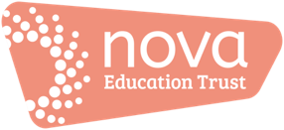 | Welcome to the final issue of our ‘Work Hard; Be Kind; Well-being’ newsletter!  We hope that you have enjoyed reading the newsletters and found them useful. Have a lovely summer; take care and be safe. We shall see you very soon….  01. What is ‘mental health and well-being’?  It’s a term we hear a lot but what does it mean?  Dictionary definitions tell us that it’s about comfort, health and happiness. Essentially, it’s about our emotional as well as our physical health: keeping our minds and our bodies healthy!  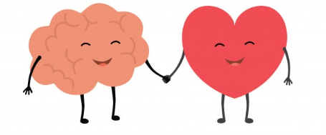  Here’s a short video which ‘talks mental health’… https://www.youtube.com/watch?v=nCrjevx3-Js  0.2 Support  Click here for a range of support - https://www.childline.org.uk/  If you can’t sleep – https://www.childline.org.uk/get-involved/articles/5-tips-to-help-you-get-to-sleep/?in_type=articlecontent  If you feel anxious - https://www.childline.org.uk/info-advice/your-feelings/anxiety-stress-panic/  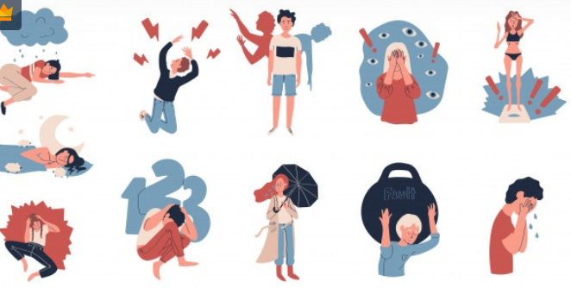  https://www.mind.org.uk/information-support/for-children-and-young-people/  https://www.childline.org.uk/get-support/contacting-childline/  0.3 Information  https://www.bbc.co.uk/newsround  https://www.bbc.co.uk/iplayer/episode/m000kl33/newsround-30062020  https://www.bbc.co.uk/programmes/b01s2dct  https://www.bbc.co.uk/newsround/51318780  04. Activities  - Try these 5 things to help you feel better inside:  https://www.bbc.co.uk/teach/five-ways-to-help-childrens-wellbeing/zfb2d6f  - Listen to Firbeck’s latest video on the school website:  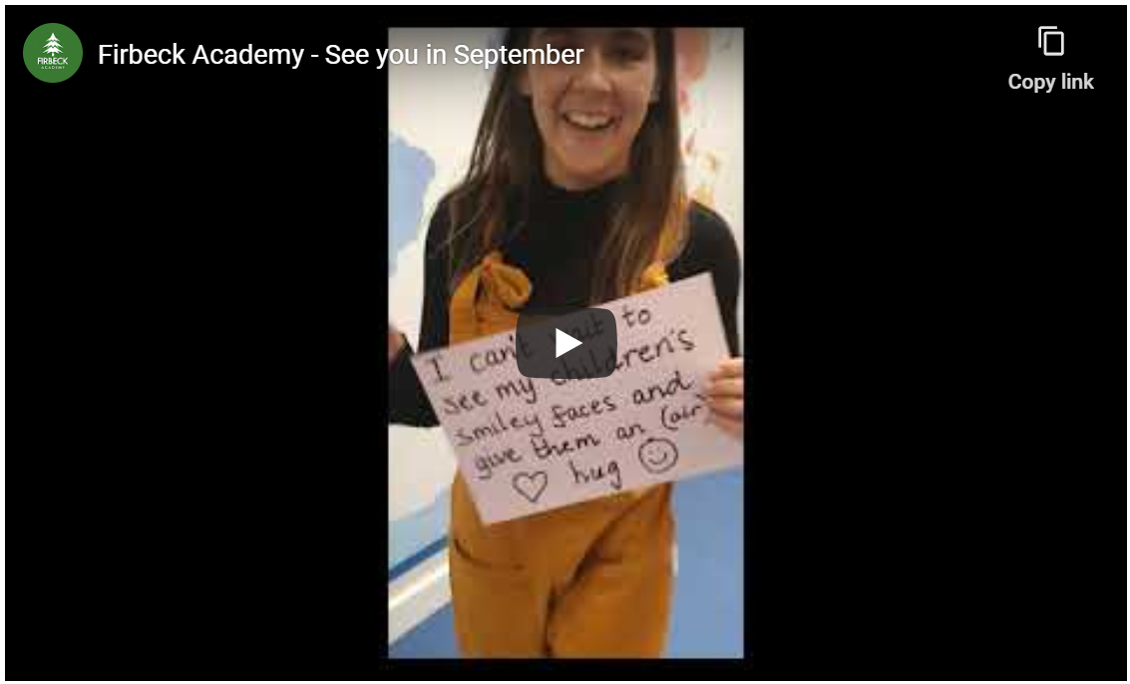  Contact us  The main contact email to use for your school for general enquiries is [admin@firbeck.org.uk]  - Look at these pictures and try them out to make yourself fell good :  https://www.partnershipforchildren.org.uk/uploads/Files/PDFs/Resilience%20Activities /Ways%20to%20Feel%20Better.pdf
- Talking mental health and well-being… what is it?

- Support

- Information

- Activities

