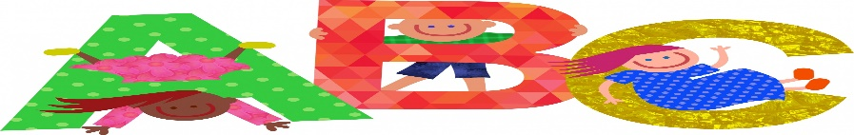

Dear Parents and Carers, we hope you had a good summer! We are looking forward to getting to know you and your child.

This half term we shall be exploring our local area through the topic of ‘Wonderful Wollaton.’ We shall be taking a local walk to Wollaton Park, spotting the local landmarks along the way. If you have any knowledge of Wollaton or Bilborough local history, please come and talk to us.

In Phonics we shall be recapping on the phases 3,4 and 5 of Letters and sounds. Try these games at <https://www.phonicsplay.co.uk/resources/phase/3>.

In English we shall be reading Five Minutes Peace and Peace at Last by Jill Murphy. We shall be exploring characters and settings and write our own. Our Grammar includes: Rainbow Grammar, leaving spaces between words, beginning to punctuate sentences using a capital letter and a full stop and using capital letters for the names of people and places.

**Firbeck Academy Newsletter Year 1 Autumn 1**

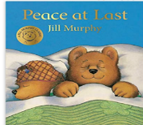



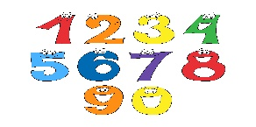

**Maths**

In maths we shall be consolidating our understanding of numbers to 10 Through ‘Maths No Problem.’ Children will be given opportunities to talk about maths and explore maths in practical contexts, including addition and subtraction and place value.

**Reading**

Each week your child will be given a reading book. It is important that you share this with your child every evening. Please encourage your child to use their phonic sounds to sound out the words. Try <https://www.topmarks.co.uk/english-games/5-7-years/letters-and-sounds> to help with this. Talk about the pictures and the story. Please sign the diary to support us in encouraging your child to read.

**N.B. Please return the book every day** as we shall be having a quiet reading time in class. **Books will be changed every Thursday.**



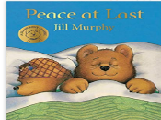

In **Science** we shall be learning about the five senses. We shall be listening to sounds on sound walks, smelling different aromas and tasting different foods. If your child has any allergies please let you know. However, we will inform you of this activity nearer the time.

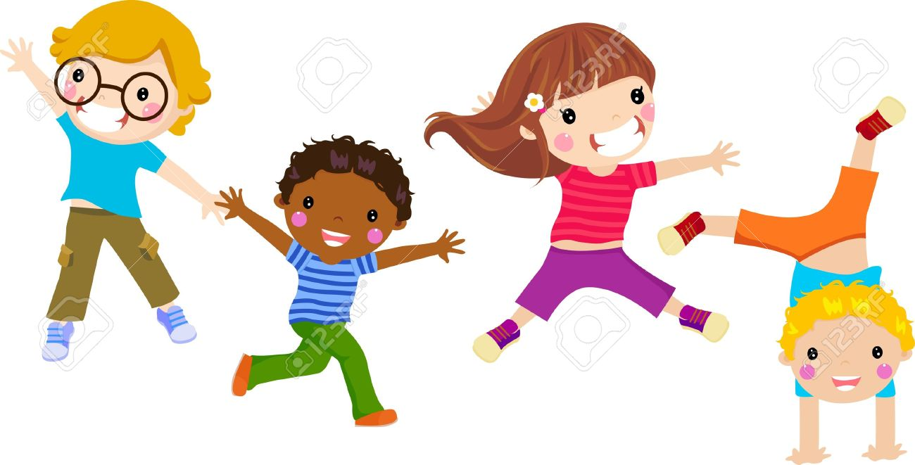

In **R.E.** we shall be thinking about Christianity and the Creation. We shall reflect upon how we can look after the Earth and everything in it. As part of our **PSHE ‘Jigsaw’** Curriculum We will be learning about our rights and responsibilities. As part of this will be reflecting upon our emotions, particularly at the start of the day and the strategies we can use to help us stay calm. If you have any questions please ask

**Miss Ward or Mrs Mitchell**.

 Thank you!

In **P.E**. we shall be exploring dance. Please ensure your child has their P.E. kit in school with their name clearly labelled on it. Encourage your child to dress and undress themselves. Velcro trainers are ideal footwear for P.E.