Age Range: EYFS (Activities for children in Nursery and Reception)
Learning Project - to be done throughout the week
The project this week aims to provide opportunities for your child to learn more about different viewpoints. Learning may focus on physical viewpoints in terms of what you can see outside of the window at home, what others can see looking into your home and then progress onto personal viewpoints and of others.

- What can you see out of your window?-
  - Ask your child to look out of a window in the house and draw what they can see. Look out of a different window (e.g. back or side of the house), draw what they can see. Look at the two pictures together and discuss what is the same in both pictures (e.g. the sky) and what is different.

- Record how many cars/ people walk past your house-
  - Set a timer for 5 minutes on your phone or tablet. Draw out a simple grid (as below) and ask your child to put a tick in the right place every time a person or car goes past. When complete, can they count up the ticks and write the matching numeral? Were there more people or cars?

- How do we differ from others?-
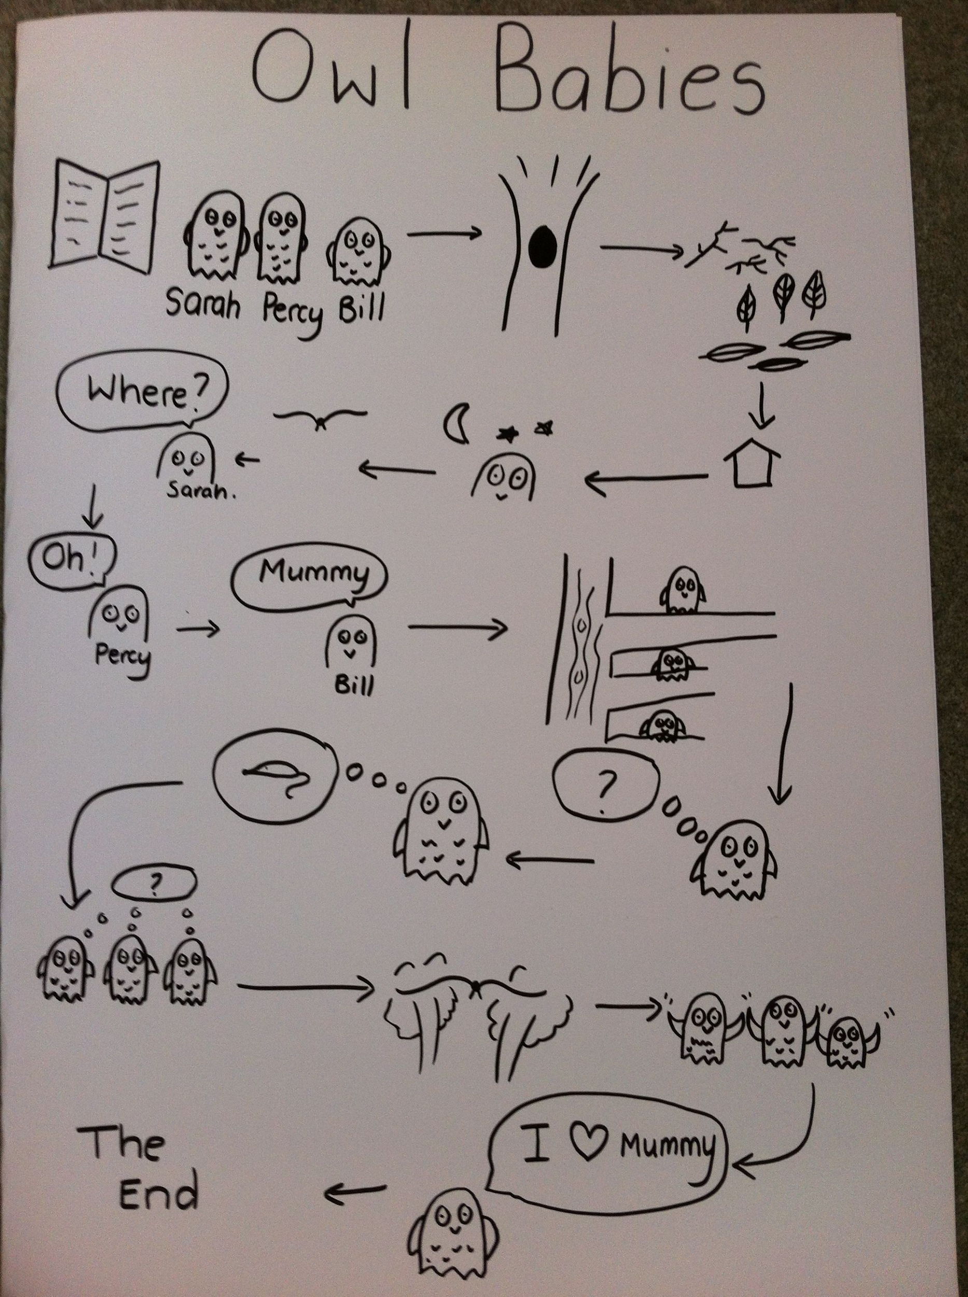
  - Ask your child to look in a mirror at their hair colour, eye colour, skin colour. Ask them to create a self-portrait using either felt-tips, crayons or paint. Look at some pictures in books and magazines. Does everyone look the same way as them? How do people look different?

- Imagine another world outside the window-
  - Close the curtains and ask your child to imagine that the house is in a new imagined world. What do they imagine? Is it snowy? Are there dinosaurs/ monsters in the new world? Ask them to tell you a story about it…
Your child could create a story map to show what happens in their imaginary world (see right).

- Go on a sight hunt-
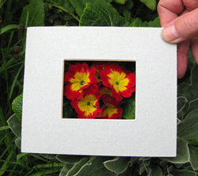
  - Support your child to make a viewfinder. Cut out a square of card from an old cereal box/ cardboard. Cut a smaller square out of the centre. Take your viewfinder around the house and garden and explore what things you can see. Alternatively, you could create a pair of binoculars as pictured.
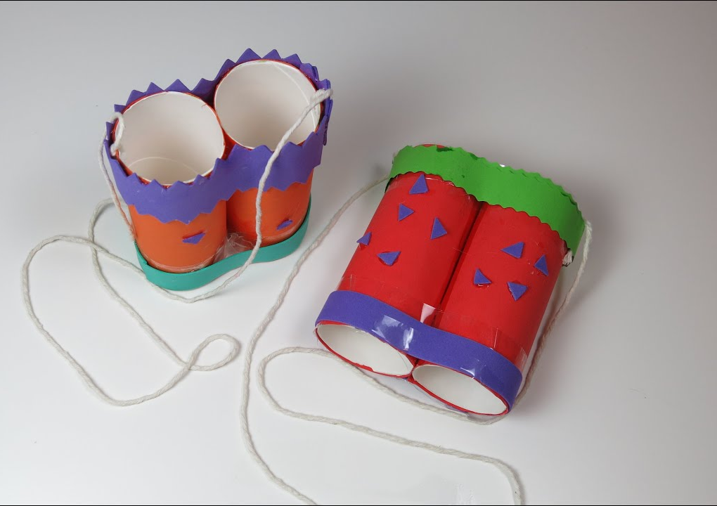
  - Your child could write a list of the things they see or draw/ paint a picture.
  - If you have a tablet or phone that could be used by your child they could do the same activity but using photographs to record.

Additional learning resources parents may wish to engage with
Classroom Secrets Learning Packs - These packs are split into different year groups and include activities linked to reading, writing, maths and practical ideas you can do around the home.
Twinkl - to access these resources click on the link and sign up using your own email address and creating your own password. Use the offer code UKTWINKLHELPS.
Headteacherchat - This is a blog that has links to various learning platforms. Lots of these are free to access.
Tweet us any of your work @FirbeckPrimary #HomeLearning :-)

