WELL-BEING NEWSLETTER
|
May 2020
PUPIL Issue 3

 | 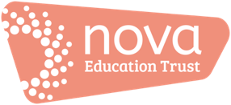 | Welcome to the April issue of our ‘Work Hard; Be Kind; Well-being’ newsletter!  There’ll be an issue of this newsletter at the end of each month until the end of this academic year (July).  This is your ‘one-stop-shop’ for information and resources to support your time out of school.  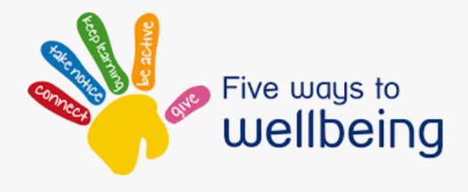  01. What is ‘well-being’?  It’s a term we hear a lot but what does it mean?  Dictionary definitions tell us that it’s about comfort, health and happiness. Essentially, it’s about our emotional as well as our physical health: keeping our minds and our bodies healthy!  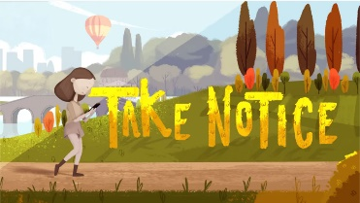  Here’s a short video which might give you some ideas about what ‘well-being’ means https://www.youtube.com/watch?v=oSIWo5nxF2A and another one with ideas for how you could develop yours:  https://www.youtube.com/watch?v=yF7Ou43Vj6c. Aimed at children but applicable to adults, too!  0.2 Support - click on the images to watch:  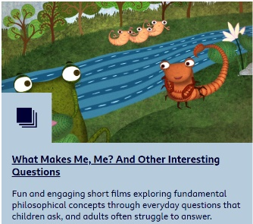  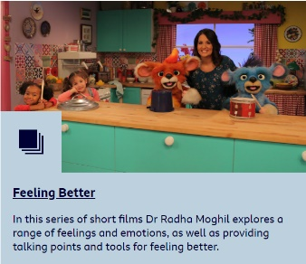  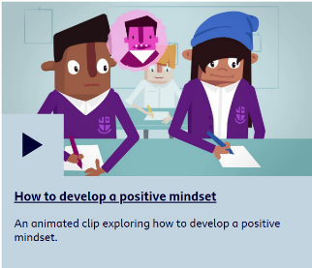  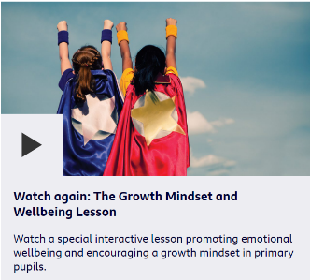  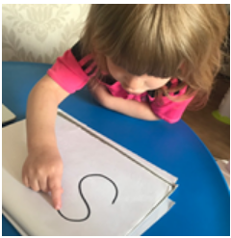  0.3 Information, guidance and updates:  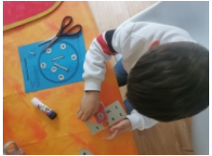  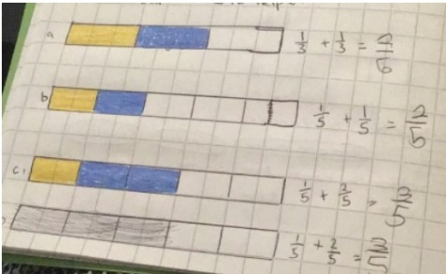  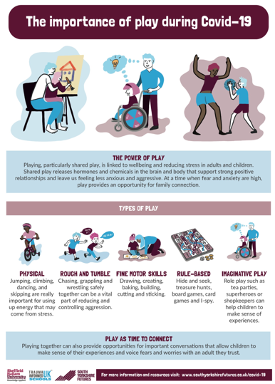  04. Special Activities  - Try learning your spellings or new words creatively…  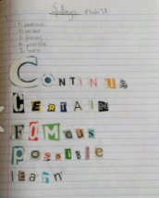  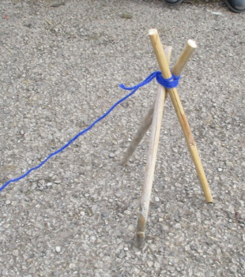  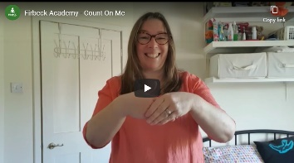  - Listen to Firbeck’s signed song on the school website:  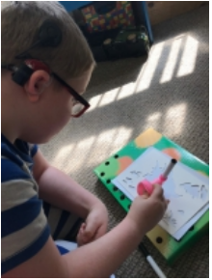  05. Activities and resources:  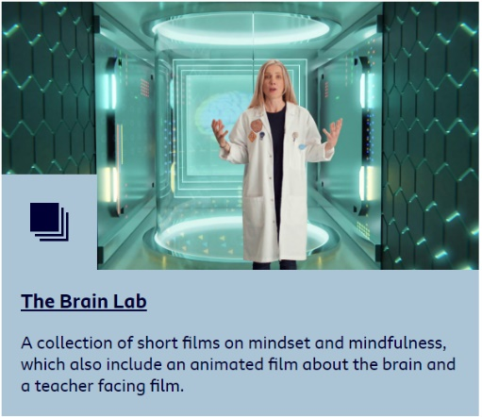  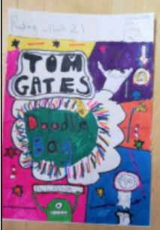  - Can you write 3 top tips for doing your favourite exercise correctly and safely?  - Would you like to reminisce? Click for a happy memory curtesy of Miss Potter…  06. ‘Here’s one I tried earlier’  This is where we share your ideas, tips and suggestions.  If you’ve got suggestions for ‘Here’s one I tried earlier’, please email Well-Being@novaeducationtrust.net  All ideas, tips and suggestions will be curated by our team and published anonymously. This could include: a recipe to try; suggestions for in-door sports and games; arts and crafts activities; ways in which you’ve used an activity or resource from this newsletter and your ‘top tips’ for doing it; any ideas that you’ve had from your experiences so far.  Thank you Teaching Staff  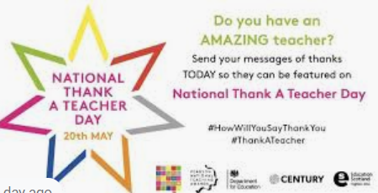  Contact us  The main contact email to use for your school for general enquiries is [admin@firbeck.org.uk]
- What is ‘well-being’?

- Support

- Information, guidance and updates

- Special features

- Activities and resources

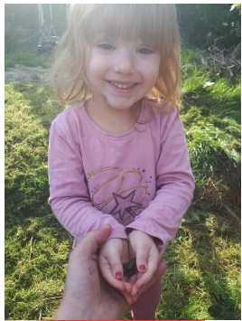
- ‘Here’s one I tried earlier’

