Rhymes
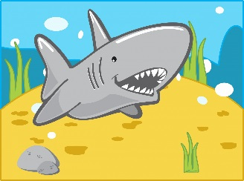
Counting rhyme – 1,2,3,4,5 – Shark.
(This is sung to the same tune as 1,2,3,4,5 –fish.)
Count on your fingers as you sing the rhyme.
1,2,3,4,5 once I caught a shark alive.
6,7,8,9,10 I don’t think I’ll do that again.

Movement rhyme –Stand as tall as a house
As you say the rhyme do the actions together.
Stand as tall as a house.
Curl up as small as a mouse.
Shake your hands, wiggle your toes.
Turn around and touch your nose.

